Android Final Exam

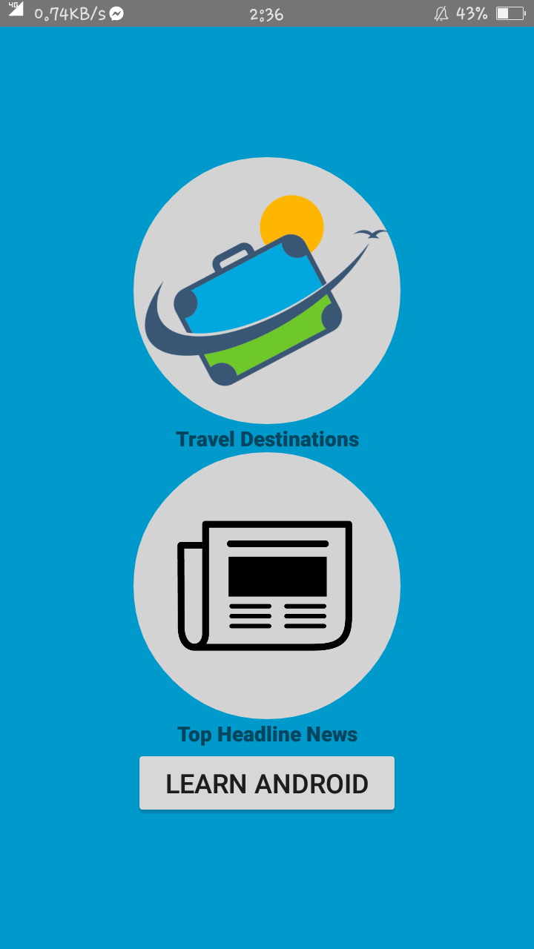**Travel Mate**

This the the first activity of my android exam which contains maps and news and learn android activities.

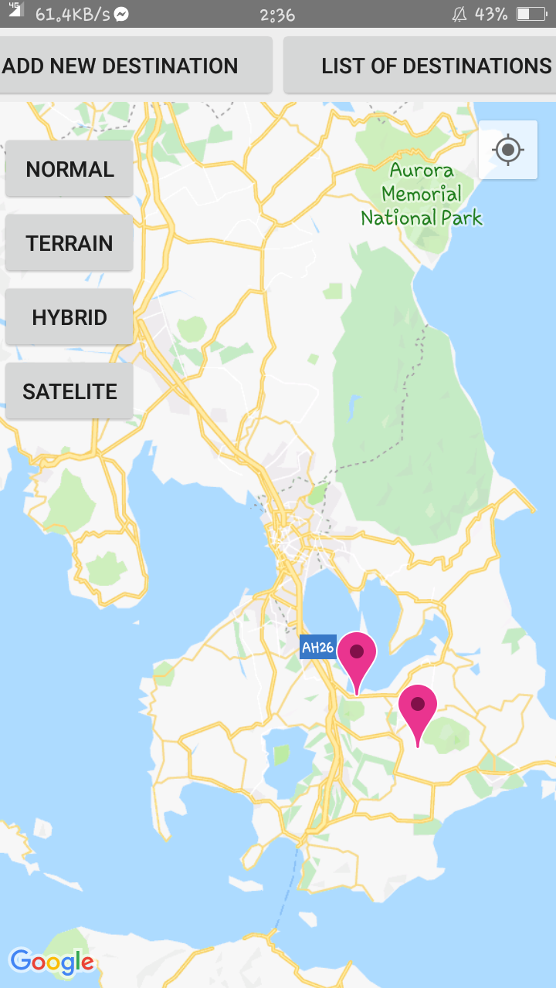

This my maps activity which contains pinpoints of travel destinations which was fetch from the database using JSON parsing method. It also contains button that modify the type of map is displays.

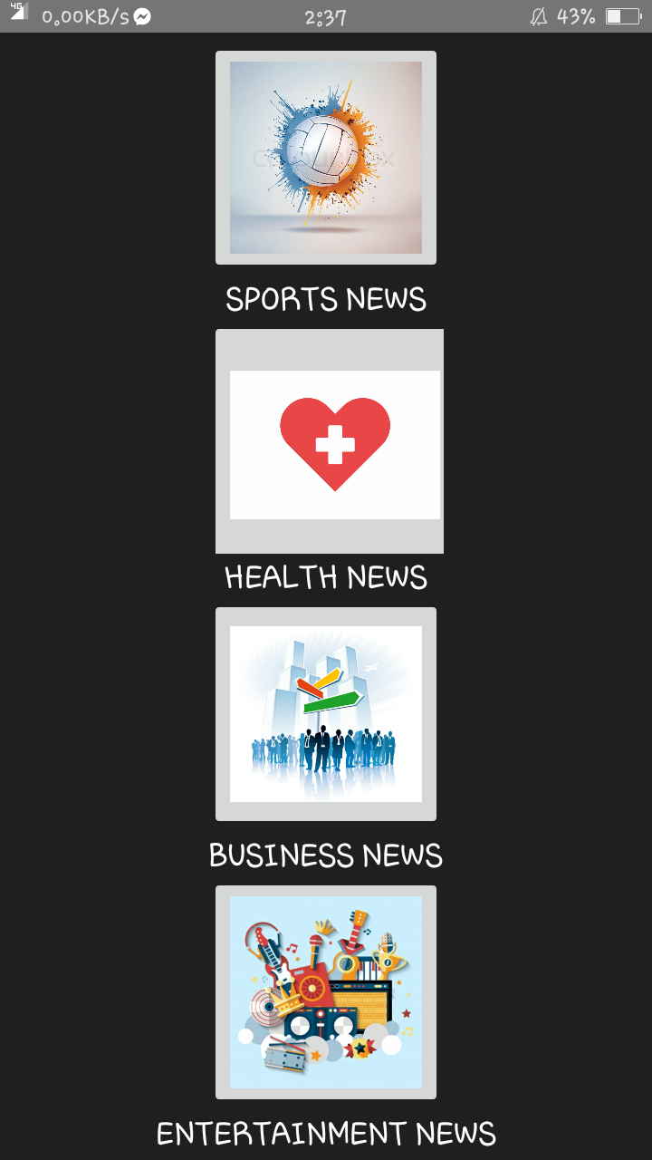

This is my news activities which contains news on different new sources. Which was fetch from the NEWAPI using JSON parsing method.